Project Design Phase
Proposed solution
Date | November 2, 2025
Team ID | F53C03230D9D3649CD4402B24FF15FEB
project Name | Educational organization using ServiceNow

1. Solution Title:
Educational Management System
2. Executive Summary:
The Educational Management System is a custom ServiceNow application designed to solve the core inefficiencies of manual student administration. By leveraging custom tables, form automation, and client-side scripting, this solution provides a single, centralized platform for managing student admissions and academic progress, thereby reducing errors, saving time, and providing clear visibility into student data.
3. Solution Components:
- Central Data Hub (Tables):
  - A parent table Salesforce will store all core student data.
  - An Admission table will extend this parent table to manage the admission-specific data and workflow.
  - A Student Progress table will link to a student's record and store all academic performance data.
- Smart, Automated Forms (Client Scripts):
  - Admission Form: The admission form will feature auto-population for addresses based on pincode, reducing entry time. A visual process flow will guide admins through the admission stages.
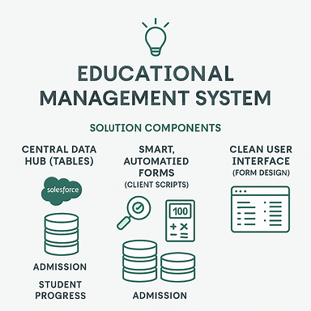
  - Student Progress Form: This form will function as an automated calculator. When a teacher enters marks, the Total, Percentage, and Pass/Fail Result will be calculated and displayed instantly. All calculation fields will be read-only to ensure data integrity.

- Clean User Interface (Form Design):
  - All forms will be organized with logical sections and multi-column layouts, transforming cluttered pages into clean, intuitive interfaces that are easy to read and use.

